## Configure the project for Debuging

### Prerequisites

* Debug to watch value of variable, state…
* Established RN enviroment.

### Steps to debug MAC-APP

* Create a new project: **npx react-native init DemoProject**
* Open with VS Code. Go **App.js file** and change code:

const App: () => React$Node = () => {

  let a = 8;

  let b = 2;

  let c = a + b;

  return (

    <>

      <View style={{flex: 1, justifyContent: 'center', alignContent: 'center'}}>

        <Text style={{fontSize: 30, textAlign: 'center'}}>

a= {a} ; b={b}

        </Text>

        <Text style={{fontSize: 40, textAlign: 'center'}}>

          Sum a and b is {c}

        </Text>

      </View>

    </>

  );

};

* Open terminal and run  **react-native run-android**:

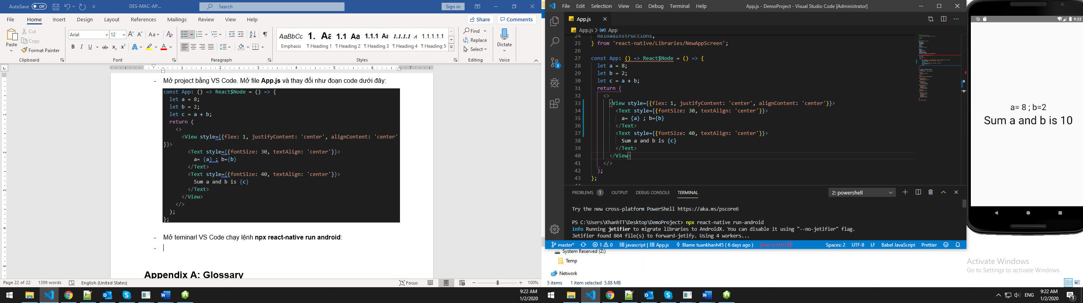

* In Android emulator **CTRL M** click **Debug**

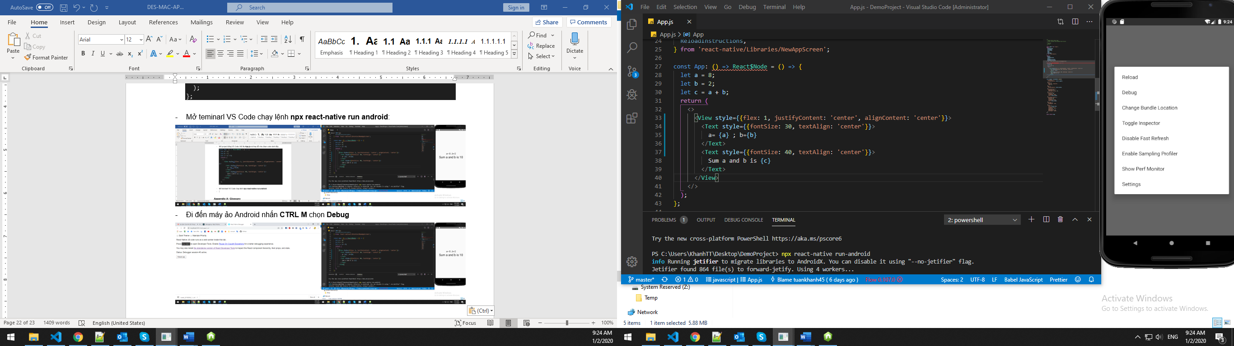

* Note: Chorm with default web brower

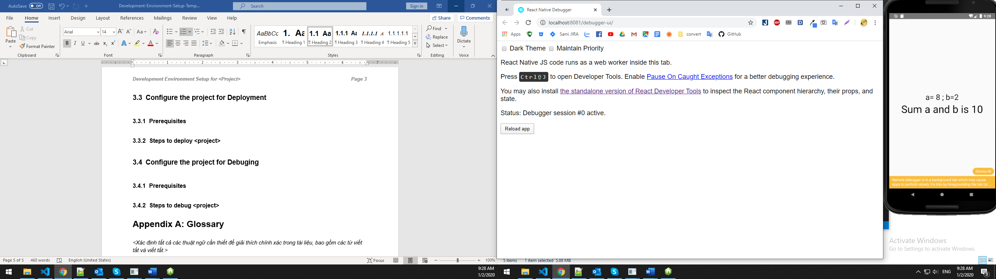

* Press **F12** go to debug. Watch Console.log Sources …

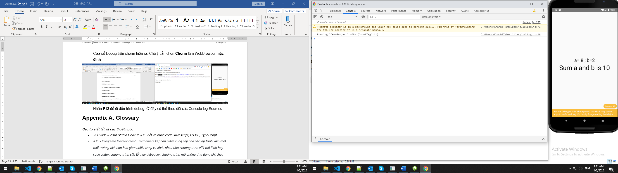

* Press CTR P to find debug find. Example App.js

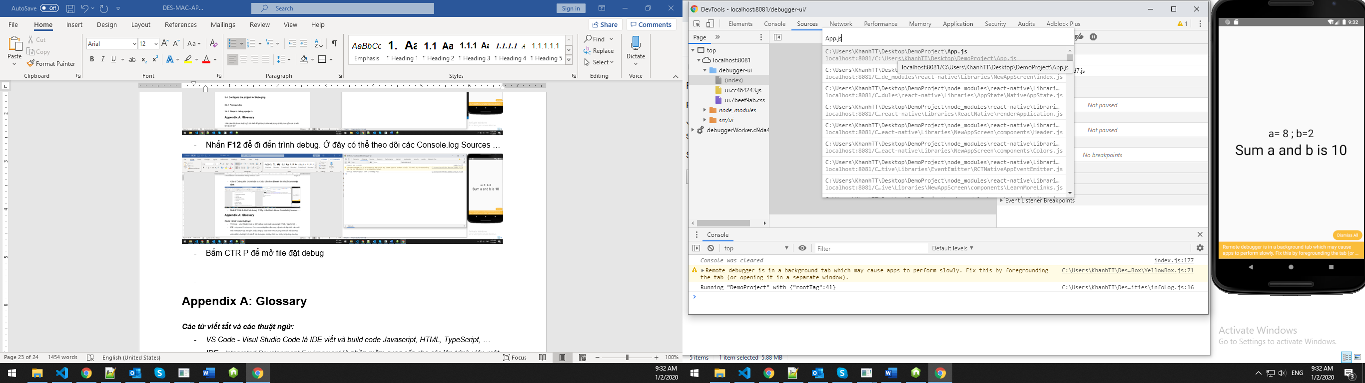

* Create breakpoints to debug. Choose **Watch** to watch the data:

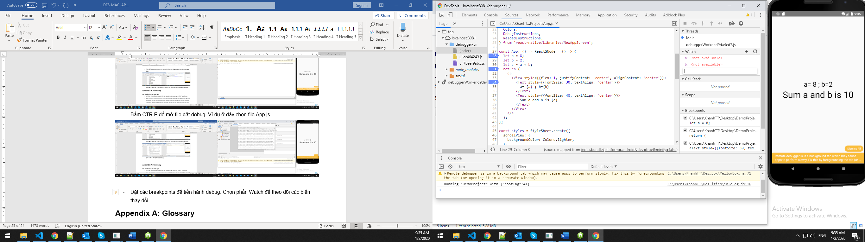

* Reload App again to Debug:

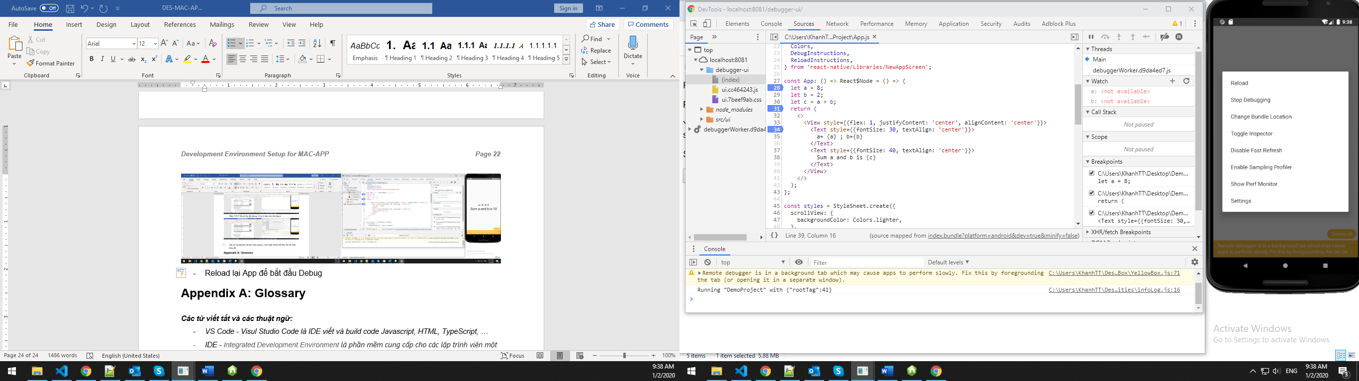

* Choose Resume button or **F8** to continue debug step:

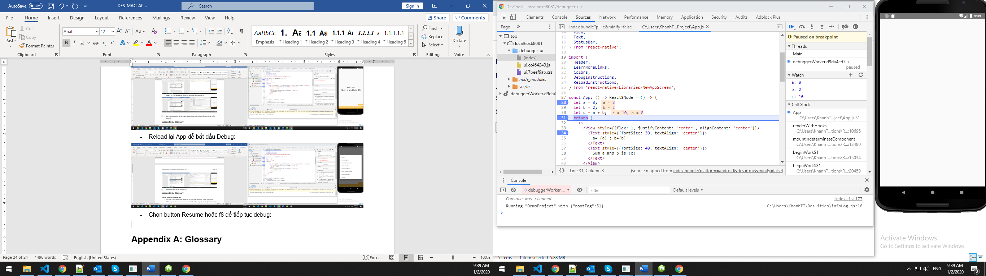

* Keep going to finish.

